Day 7: Operation Fleet Under

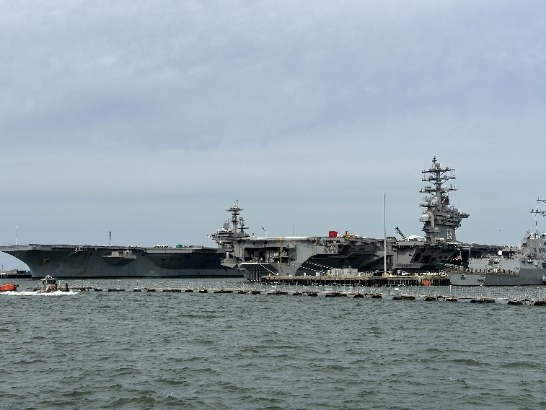

*Here are a handful of naval ships moored together, but grey is the only colour in sight. They all look the same! Can you help identify them?*

*What is the MMSI number for the left-most ship?*

Zooming in to the picture, there are three large ships visible. At least the right one is American, because of the flag. The middle one seems easy to identify because of the large ‘69’ number. Let’s do a Google Reverse Image search on this particular ship. I get a number of results with different numbers. They seem to be denoted by the prefix CVN. So, let’s Google for CVN 69. This seems to be USS Dwight D. Eisenhower. This information may come in handy later. Now, let’s try to find out the location of where these ships are moored. To do this, I do a Google Reverse Image search on specifically the netted barrier and orange floating device. Unfortunately, this doesn’t really result in any good images. So, I tried to do a Reverse Google Image search solely on the left-most ship. Scrolling through the results, I find one page that shows a similar ship, particularly the small platform on the side and the pole standing on the ship (see below). The page mentions this ship is called the USS Gerald R. Ford, which matches with the other ship named after a US president. However, the MMSI number for this ship is not the correct answer to this challenge. So, I decide to do a Google Reverse Image search for the entire picture. One image pops up that mentions the USS Dwight D. Eisenhower ship. Moreover, this picture shows a similar barrier as the one in the challenge picture (see below). Clicking on this picture, it is revealed that the ship was docked at the Norfolk Naval Station. On the Wikipedia page of this naval station, a list of 5 USS aircraft carriers (all named after US presidents) is presented, including the USS Dwight D. Eisenhower. Maybe we can find the correct match of the other ship if we look through these options. The first ship is called USS John. C. Stennis (CVN 74), and this one too seems very similar to the left-most ship in the challenge picture. To confirm, I Googled for: CVN-74 CVN-69 Norfolk. The first hit is an image of exactly these two ships side by side in the Norfolk Naval Station. So, this might be the ship we are looking for. The MMSI number for this ship unfortunately is also incorrect. At this point, I try to brute force the answer with the remaining two ships from the Wikipedia page. Eventually, the correct ship is the USS George H.W. Bush, with MMSI code:

**369970663**.

